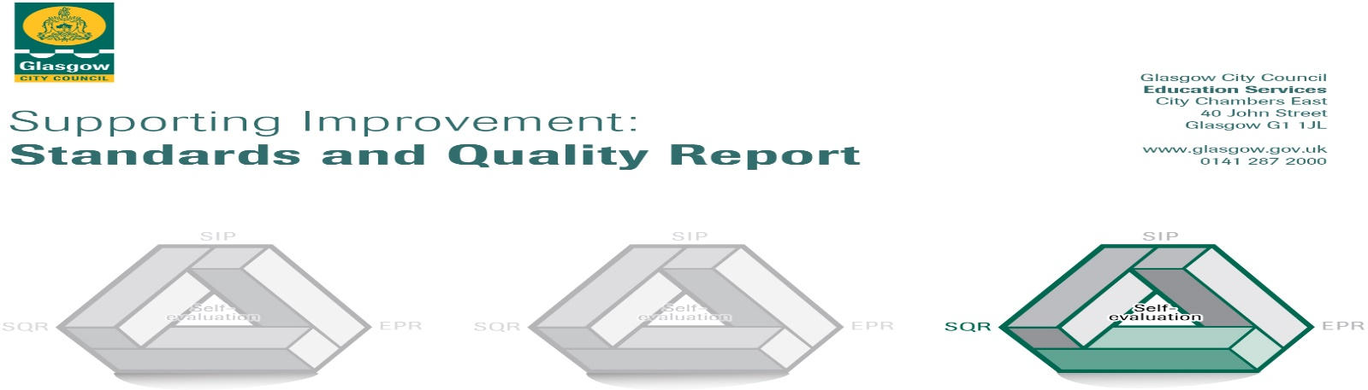

Cardinal Winning Secondary Session: 2018-19
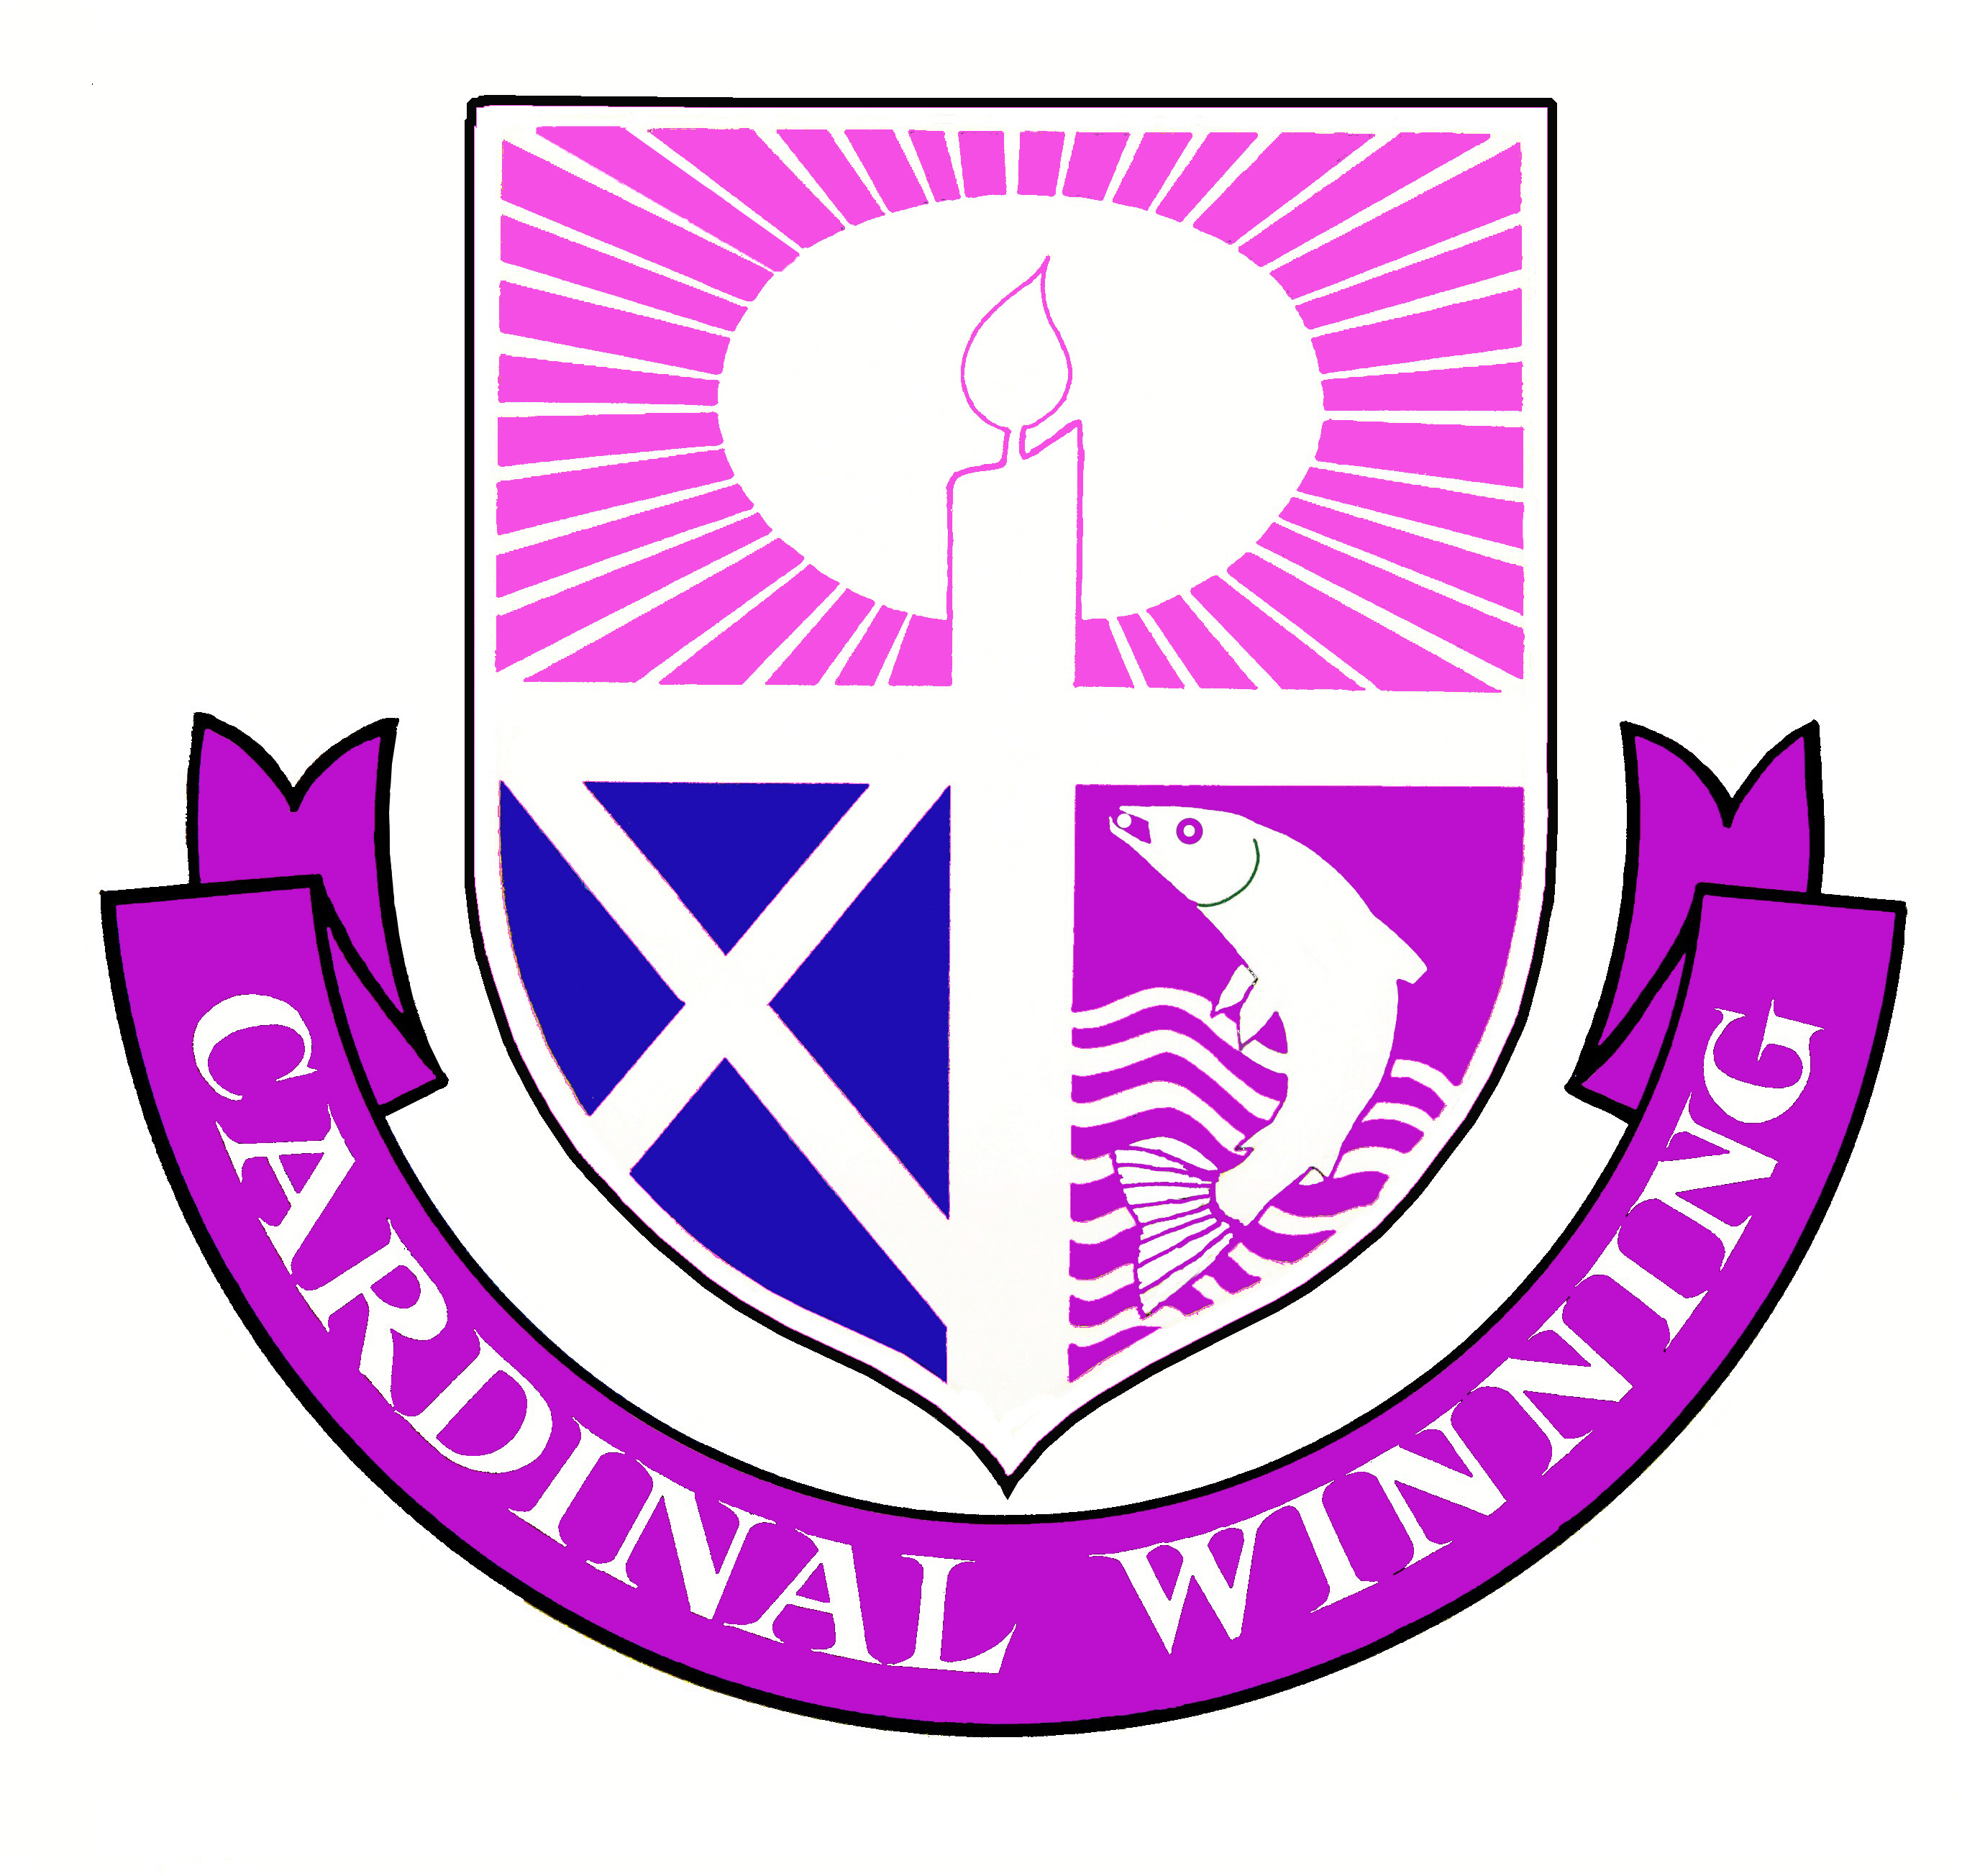

The summary report is provided for parents/careers and partners to outline our achievements this session and our priorities for next session. Throughout this session we have taken forward our priorities as detailed in our school improvement plan. Through our processes of self-evaluation, we have identified how we can improve outcomes for our children and young people.

Our achievements and improvements this year.
Key Developments (Leadership of Change)

It is an exciting time at the school as we are currently undertaking a review and renewal of our Values, Vision and Aims. This ongoing process has helped foster even stronger collaboration between staff members, young people, parents/carers and our key learning & teaching and employability/skill development partners. Together we have been engaged in the process of identifying a new set of co-created core Values without ever losing sight of our number one objective – high quality education of young people.

Our new School Values are ready to be shared in the new session and now we have the opportunity to bring these values to life in our community, ensuring they are universally understood, demonstrated by our community members and inform our Vision for the next 3 to 5 years. This Vision Planning will be undertaken by our school community in the coming Autumn.

In addition to our focus on renewing our School Values, we have continued to grow as a school community where self-evaluation is embedded in our daily activities and is at the heart of our improvement planning. Our Senior Leadership Team has engaged in a new approach to improvement planning this session and this has promoted greater ownership of our next steps and has allowed the school to refocus on three key areas for improvement: Leadership of Learning;
Learning, Teaching and Assessment; Ensuring Wellbeing, Equality and Inclusion. All staff in the school have structured improvement planning for the coming year using this triangle framework.
Staff will be encouraged both to deliver and participate in professional learning programmes within the school in order to enhance professional knowledge, understanding and skills that will impact positively on our learners’ progress.

Throughout the year, all of our teaching staff have undertaken robust quality assurance projects to evaluate the quality of learning and teaching in our classrooms. This has been an exciting process and is only the beginning in our mission to continually develop, adapt and improve our teaching methodologies in ways that best challenge and support our wonderful learners.

Many of our staff this year have led change initiatives to the benefit of our young people. One such initiative was the improved partnership working with St Mungo’s Academy which allowed some of our S6 pupils to achieve a full N4 Media Course Award. Another involved a group of S5 young people engaging in the Duke of Edinburgh programme and a group of S4 youngsters engaged with the Clydesdale Rowing Club for the first time winning the award for most improved school at the Glasgow Schools Rowing Regatta. Our Pupil Council and School Captains programmes have resulted in positive impact for learners: the former decided to spend some of the school budget devoted to Pupil Council initiatives on improving the playground resources; the latter developed leadership skills by undertaking training to provide pastoral support to our younger school members.

Developments in Learning, Teaching and Assessment

The school staff’s key development focus this year has been on further enhancing the quality of learning and teaching. This important focus will continue in the coming year. In almost all lessons, young people are fully engaged, active and motivated participants. In most lessons the purpose of learning is clear and referenced throughout. In the majority of lessons, learners’ experiences are appropriately challenging and matched to learners’ needs. In the coming year we look forward to engaging in a two day Validated Self-Evaluation with senior leaders from each of our three Learning & Teaching Network Partner Schools. This will provide us a great opportunity to share our own evaluation of learning and teaching in Cardinal Winning Secondary with that of our partner schools VSE Team in order to identify the right next steps to further improve our learners’ experiences.

As we renew our school values, so will we identify new ways of celebrating the success of those young people putting our values into action. This year we have moved towards a more restorative approach to challenging behavior and we have aligned our Celebrating Success Assemblies with our current Values statement.

Assessment evidence is noted as being valid and reliable. This was evidenced by the hugely positive feedback received from our school’s verification exercise for departments assessing young people at National 1 and National 2. This progress will continue in the new year with weeks of the year identified to allow sharing of standards sessions between colleagues within the school and between ourselves and other secondary schools. Our Pupil Equity Fund has allowed us to introduce new resources to promote improvement in Literacy and Numeracy levels. Our engagement with ReadingWise will target those young people in S1 – S3 who require more support in developing their reading and comprehension skills, while a number of new and engaging Numeracy tools will be introduced in the coming session to further support our learners’ Numeracy skills.

Progress in Promoting Wellbeing, Equality and Inclusion

Most staff have a confident understanding of the wellbeing indicators and how these are used to provide a holistic assessment of a young person’s wellbeing. All teaching staff and some key Support for Learning staff contribute to our Wellbeing Assessments and Plans which are completed for all pupils on Staged Intervention levels 3 and 4. Young people contribute to assessment of wellbeing and target creation as they are supported by registration teachers and Year Heads to engage with the My World Triangle and the Glasgow Motivation and Wellbeing Profile. Similarly, where appropriate young people have Risk Assessments and these are reviewed to evaluate impact at key stages during the year.

The majority of staff know about the general aims of Nurture Principles. In the coming year, we will re-introduce an S1 Nurture Group for appropriate young people and there will be the opportunity for all staff to engage in professional learning on Nurture Principles and Practice.

The school has established a Mental Health and Wellbeing Committee and this will continue to develop next year with identified targets to promote wellbeing of our staff and young people. In addition to this group, the school community after much consultation has decided to use some of the Pupil Equity Fund to engage in partnership work with LifeLink Youth Counseling in the coming year. This partnership will provide three sessions of one to one counseling a week in school for those young people who will most benefit from such support.

This year we have continued to promote the health and wellbeing of our learners in a variety of ways from our energetic and diverse Friday Commonwealth Activities Programme to our Breakfast Club provision to our resilience and confidence building residential trips offered to all young people.

Progress in Children’s Learning/Raising Attainment and Recognising Achievement

Progress in Literacy and Numeracy for our young people in the Broad General Education (S1 – S3) continues to improve, particularly in those achieving First Level in Reading, those achieving Early Level in Writing and those achieving Early and First Level in Numeracy. Our three year trend can be seen below:

 | Reading
 | Achieved Early Level | Achieved First Level | Achieved Second Level | Total
2017 | 16 | 10 | 3 | 29
2018 | 19.8 | 13.2 | 2.8 | 35.8
2019 | 19.6 | 17.0 | 2.8 | 39.4

 | Writing
 | Achieved Early Level | Achieved First Level | Achieved Second Level | Total
2017 | 16 | 11 | 2 | 29
2018 | 20.8 | 14.2 | 1.9 | 36.9
2019 | 28.6 | 8.9 | 2.7 | 40.2

 | Numeracy
 | Achieved Early Level | Achieved First Level | Total
2017 | 23 | 7 | 30
2018 | 30.2 | 10.4 | 40.6
2019 | 30.4 | 10.7 | 41.1

Our Annual Awards Ceremony celebrated a range of achievements and successes in attainment including

- Kelvin College Award for Food Service Student of the Year
- Kelvin College Award for Art & Jewellery Student of the Year
- 24 young people receiving the Caritas Award
- 9 young people receiving the Level 4 Sports Leader Award

As ever we have worked hard this year to ensure our learners grow in independence and find sustainable positive destinations on leaving Cardinal Winning Secondary.

63% of our young people participated in residential stays this year.
21% of our young people in 2018/19 travelled independently to school.
We have 100% positive destinations for our school leavers with 85% entering further study at college, 11% engaging with full time employment and 4% entering a training programme.

Here is what we plan to improve next year.
Key Developments (Leadership of Change)

- Finalising and sharing our new School Values with all stakeholders
- Collaborating as staff, parents/carers, young people and partners to ensure these new Values inform our 3 – 5 year Vision
- Increase staff’s engagement with professional learning in and out of school
- Supporting our young people by increasing opportunities for leadership in the school.

Developments in Learning, Teaching and Assessment

- Engaging in a validated self-evaluation visit with our partner Learning & Teaching Network schools

- Reviewing and updating our course planning.

- Improving our staff collegiate focus on learning and teaching, understanding standards, tracking pupil progress and quality assurance.

- Developing our approaches to supporting our young people to lead learning in the classroom.

Progress in Promoting Wellbeing, Equality and Inclusion

- Starting an S1 Nurture Group to provide targeted support and developing a programme of Nurture Staff Training to ensure Nurture Principles and Practice is better understood and implemented to the benefit of our school community

- Improved pupil planning putting young people and parents/carers at the heart of the planning process

- Engagement with a new partner in LifeLink Youth Counselling to improve the health and wellbeing of our young people

- We will continue to work towards becoming a Language and Communication Friendly Establishment

Progress in Children’s Learning/Raising Attainment and Recognising Achievement

- We intend to develop a new Tracking and Monitoring Programme for the school to promote effective interventions to support learners’ progress

- We will introduce a new Literacy Intervention programme called Readingwise to further enhance our S1 – S3 learners’ reading skills

- We look forward to employing new Pupil Equity Funded Numeracy resources to engage our learners and to continuing our progress with the Glasgow Counts initiative

- A Wider Achievement Database will be established to ensure all our young people are being encouraged and supported to achieve beyond the classroom.

How can you find out more information about our school?
Please contact us directly if you require further information or if you wish to comment on the report.

The contact e-mail address is: Headteacher@cardinalwinning-sec.glasgow.sch.uk

Our telephone number is: 0141 778 3714

Our school address is: 30 Fullarton Avenue, Glasgow, G32 8NJ

Twitter @cardinalwinnin1

Further information is available in: newsletters, the school website, our school app and the school handbook

